Exploratory Data Analysis & Data Cleansing Approach
Phillip Smith | 7/8/2026 sales-customer-segmentation
GitHub: customer-segmentation

Introduction
The objective of this project is to segment customers into meaningful, actionable groups that the business can target with tailored marketing campaigns. I will execute an end-to-end analytical approach and apply machine learning techniques to internal transactional sales data to help the business gain a better understanding of who its customers are, how they behave, and where the greatest revenue opportunities lie. This milestone focuses on exploratory data analysis and data cleansing, establishing a clean, well-understood master file so that the customer segmentation and campaign recommendations developed in later milestones rest on trustworthy data. Because the source data is transactional rather than pre-labeled, I frame the problem as an unsupervised segmentation task and organize the analysis around the Recency, Frequency, and Monetary (RFM) behaviors that directly capture customer value.

Data Exploration
The dataset is a single sheet of 379,979 line-item records spanning a full calendar year (Jan 4-Dec 9, 2021). Each row represents one product line on one invoice. Below I list each field, role, and data type.
- InvoiceNo - Unique identifier for a transaction as a string; a leading “C” denotes a cancelled order.
- StockCode - Product identifier as a string; most are five-character product codes, with a handful of service codes (POST, DOT, M, etc.).
- Description - Product name/description as a string (3,800 distinct values).
- Quantity - Number of units on the line as an integer (negative on cancellations).
- InvoiceDate - Date and time of the transaction as a datetime (2021).
- UnitPrice - Price per unit, in GBP, as a float.
- CustomerID - Unique customer identifier as an integer (4,244 distinct customers).
- Country - Country of the customer as a string (36 distinct; predominantly United Kingdom).
Original Statistical Summary
Most fields are identifiers, dates, or categorical strings that do not yield meaningful descriptive statistics. The two numeric columns, Quantity and UnitPrice, do — and they immediately reveal data-quality issues. Quantity ranges from –80,995 to 80,995, and UnitPrice includes values as low as 0. The large negative quantities correspond to cancellations, and the zero prices to non-sale adjustments; both are resolved during cleansing so that later summaries describe genuine purchasing behavior.
Attribute | Mean | Median | Std Dev | Min | 25% | 75% | Max
Quantity | 12.13 | 5.00 | 256.59 | -80,995 | 2.00 | 12.00 | 80,995
UnitPrice | 3.48 | 1.95 | 71.70 | 0.00 | 1.25 | 3.75 | 38,970
Table 1. Descriptive statistics for the raw numeric columns (before cleansing).

Data Cleansing
Missing Values
An Excel file was analyzed and a Python script was executed which detected no missing values in any of the eight columns. Critically, CustomerID is fully populated across all records, so every transaction can be attributed to a customer and no imputation is required to build the customer-level analysis. Because there are no null values, no imputation strategy (mean/median substitution, KNN imputation, or dropping) is needed at this stage.
Record Filtering
While no values are missing, several categories of records are not valid sales and would distort any measure of customer value. I removed exact duplicate rows, non-product service lines (postage, manual adjustments, discounts, bank charges, and commissions), and any line with a non-positive unit price. Cancellations are treated separately and are deliberately not deleted — the next section explains why. The transaction master retains 365,581 purchase lines, alongside 7,840 cancellation lines held back for netting.
Cleansing Step | Records Removed | Records Remaining
Starting records | — | 379,979
Remove exact duplicate rows | 4,729 | 375,250
Remove non-product service codes | 1,799 | 373,451
Remove non-positive unit price | 30 | 373,421
Separate cancellation lines (retained, not deleted) | 7,840 | 365,581
Transaction master (purchase lines) | — | 365,581
Table 2. Record-level cleansing audit trail.
Negative Quantity Records
Every negative quantity in this dataset is a cancellation. The 8,215 rows carrying a negative quantity in the source file are exactly the 8,215 rows whose invoice number begins with “C” — I checked the correspondence in both directions and found no exceptions, and there are no zero-quantity rows at all. “Remove all negative entries” and “remove cancellations” are therefore the same operation on this data, which means the real question is not how to identify these records but what to do about the original sale that each one reverses.
Simply deleting the negative rows is not sufficient. A cancellation reverses a sale that is still sitting in the data as a positive line, so removing only the negative side credits the customer with revenue the business never kept. Matching each cancellation back to the same customer’s purchases of the same product at the same price, 85.4% are fully covered by a recorded purchase and a further 0.4% partially; the remaining 14.2% match nothing, almost certainly because they reverse orders placed before the 4 January window opens.
My rule is therefore to retain cancellation lines and net them against customer value rather than discard them. Recency and frequency are computed from purchase lines only, since a refund is not a shopping visit, while monetary value is gross spend less refunds. The table below quantifies what that correction is worth: ignoring cancellations would overstate net customer revenue by GBP 454,445, or 5.89%. The median affected customer is barely moved at 2.0% of gross spend, but 26 customers refund more than half of what they spend and 13 end up net non-positive and are dropped from the customer table entirely. Those are precisely the customers a value-based segmentation would otherwise rank far too highly.
Measure | Value
Cancellation lines retained | 7,840
Purchase lines in transaction master | 365,581
Refunded value netted out | GBP 454,445
Gross customer revenue (cancellations ignored) | GBP 8,172,028
Net customer revenue (cancellations applied) | GBP 7,717,583
Overstatement if cancellations are ignored | 5.89%
Customers with at least one cancellation | 1,420
Median refunds as % of that customer’s gross spend | 2.0%
Customers refunding more than 50% of gross spend | 26
Customers net non-positive, dropped from RFM table | 13
Table 3. Cancellation volume and the value at stake in the netting rule.
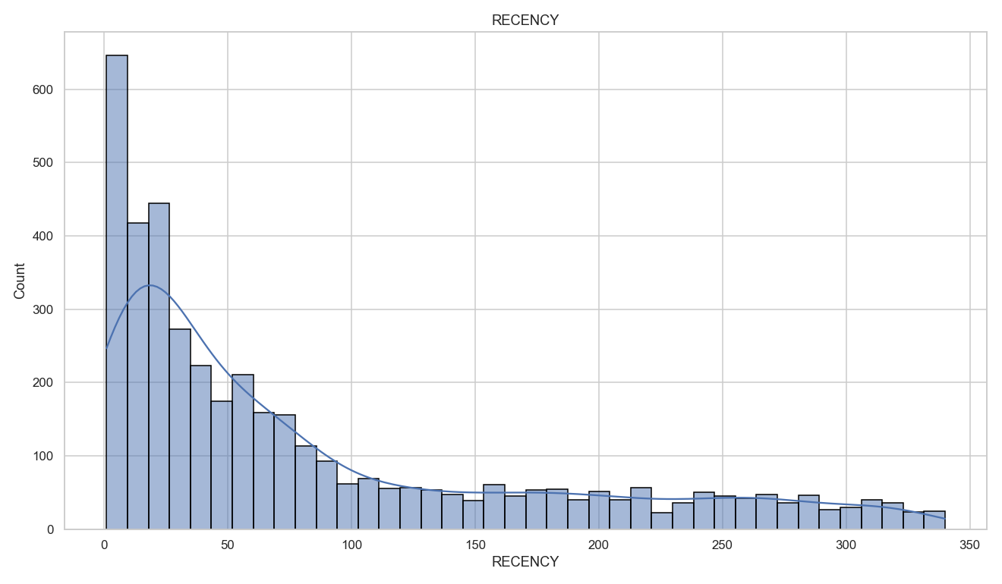
Figure 1. Gross versus net customer revenue (left), and how large refunds are relative to each affected customer’s gross spend (right).
Renamed Columns
For consistency and readability across the codebase, I standardized the column headers to uppercase, self-documenting names.
Original Header | Standardized Header
InvoiceNo | INVOICE_ID
StockCode | STOCK_CODE
Description | DESCRIPTION
Quantity | QUANTITY
InvoiceDate | INVOICE_DATE
UnitPrice | UNIT_PRICE
CustomerID | CUSTOMER_ID
Country | COUNTRY
Table 4. Column header standardization.

Data Transformation
Derived Feature: Line Revenue
I created TOTAL_PRICE = QUANTITY × UNIT_PRICE to capture the revenue contributed by each line item. This becomes the basis for the monetary component of each customer’s value.
Customer-Level Aggregation (RFM)
Because the business question is about customers, not individual line items, I aggregated the 365,581 purchase lines into one row per customer, producing a table of 4,201 customers. Following the standard RFM framework, each customer is described by three behaviors, plus an average-order-value convenience measure. Recency is measured relative to a snapshot date of December 10, 2021 (one day after the final invoice). Monetary value is net of the cancellations described above, so it reflects revenue the business actually kept; the 13 customers whose refunds met or exceeded their spend carry no positive value to segment and are excluded.
- RECENCY - Days since the customer’s most recent purchase (lower is more recently active).
- FREQUENCY - Number of distinct invoices (purchase occasions) the customer placed.
- MONETARY - Total revenue (sum of TOTAL_PRICE) the customer generated.
- AVG_ORDER_VALUE - MONETARY ÷ FREQUENCY - average spend per purchase occasion.
Log Transformation
The RFM measures are heavily right-skewed: a small number of high-value, high-frequency customers sit far above the median. Because the segmentation in the next milestone will rely on distance-based clustering (e.g., K-Means), I added log-transformed versions (log1p) of Recency, Frequency, and Monetary to compress this skew. As shown later, the log transform turns the sharply skewed Monetary distribution into an approximately normal one, which will make scaling and clustering far more stable.
Updated Statistical Summary
After cleansing, the transaction-level numeric columns describe genuine sales. Quantity and price are now strictly positive, and the extreme negatives are gone.
Attribute | Mean | Median | Std Dev | Min | 25% | 75% | Max
QUANTITY | 13.22 | 6.00 | 186.62 | 1.00 | 2.00 | 12.00 | 80,995.00
UNIT_PRICE | 2.86 | 1.79 | 4.23 | 0.04 | 1.25 | 3.75 | 649.50
TOTAL_PRICE | 22.35 | 12.30 | 320.97 | 0.06 | 4.95 | 19.80 | 168,469.60
Table 5. Descriptive statistics for cleaned transaction-level numeric attributes.

At the customer level, the RFM table summarizes each customer’s behavior. The gap between the mean and median of Frequency and Monetary confirms the right-skew that motivates the log transform.
Attribute | Mean | Median | Std Dev | Min | 25% | 75% | Max
RECENCY | 84.74 | 47.00 | 90.08 | 1.00 | 17.00 | 128.00 | 340.00
FREQUENCY | 4.05 | 2.00 | 7.05 | 1.00 | 1.00 | 4.00 | 185.00
MONETARY | 1,838.03 | 642.80 | 7,961.01 | 0.00 | 296.71 | 1,554.37 | 270,201.14
AVG_ORDER_VALUE | 373.41 | 287.34 | 471.62 | 0.00 | 173.89 | 425.96 | 13,206.50
Table 6. Descriptive statistics for customer-level RFM attributes (4,201 customers, monetary net of cancellations).

Exploratory Data Analysis
Numerical Attributes
Customer Recency is right-skewed: a large group of customers purchased within the last one-to-two months, followed by a long tail of dormant customers who last purchased 150–340 days ago. This dormant tail is precisely the population a win-back campaign would target.
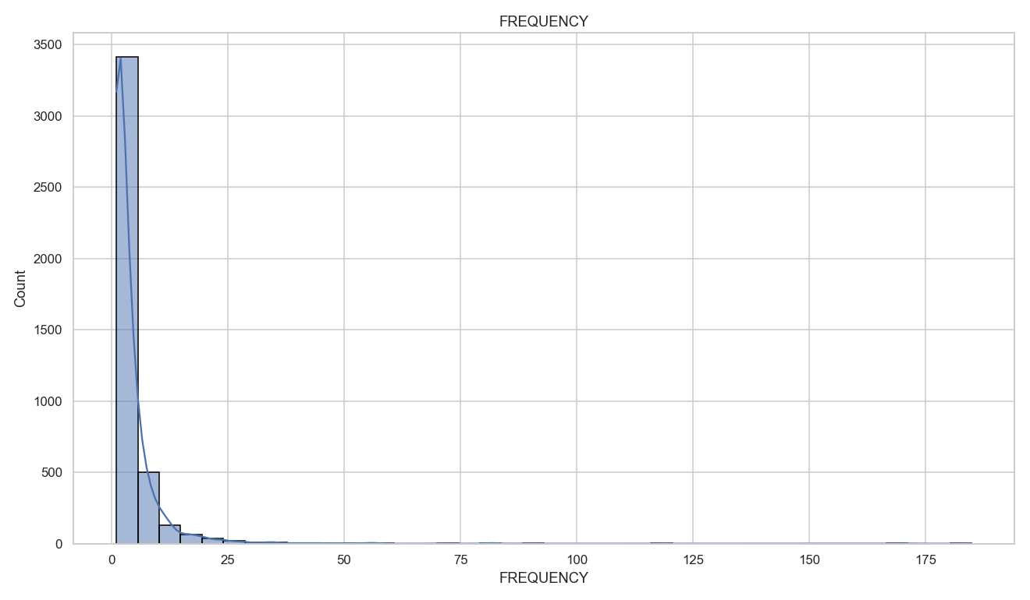
Figure 2. Distribution of customer Recency (days since last purchase).
Frequency is even more concentrated: the median customer places just two orders, while a small cohort of loyal buyers orders dozens of times. These frequent buyers are strong candidates for loyalty or referral programs.
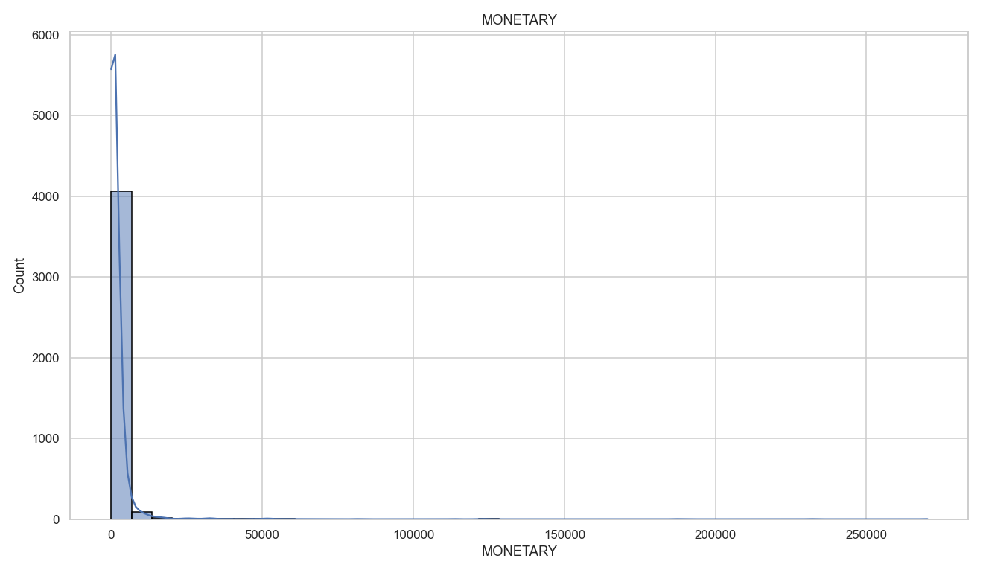
Figure 3. Distribution of customer Frequency (distinct invoices).
Monetary value shows the most extreme skew of all: raw spend is compressed against zero with a handful of customers spending into the hundreds of thousands. Applying a log transform produces an approximately normal distribution — the justification for log-scaling the RFM features before clustering.
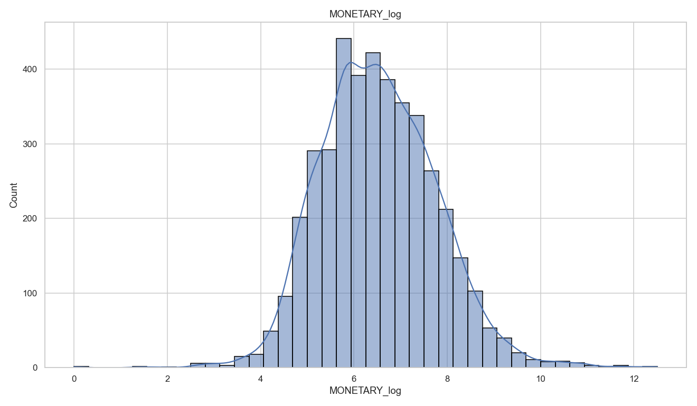
Figure 4. Raw Monetary distribution - severely right-skewed.
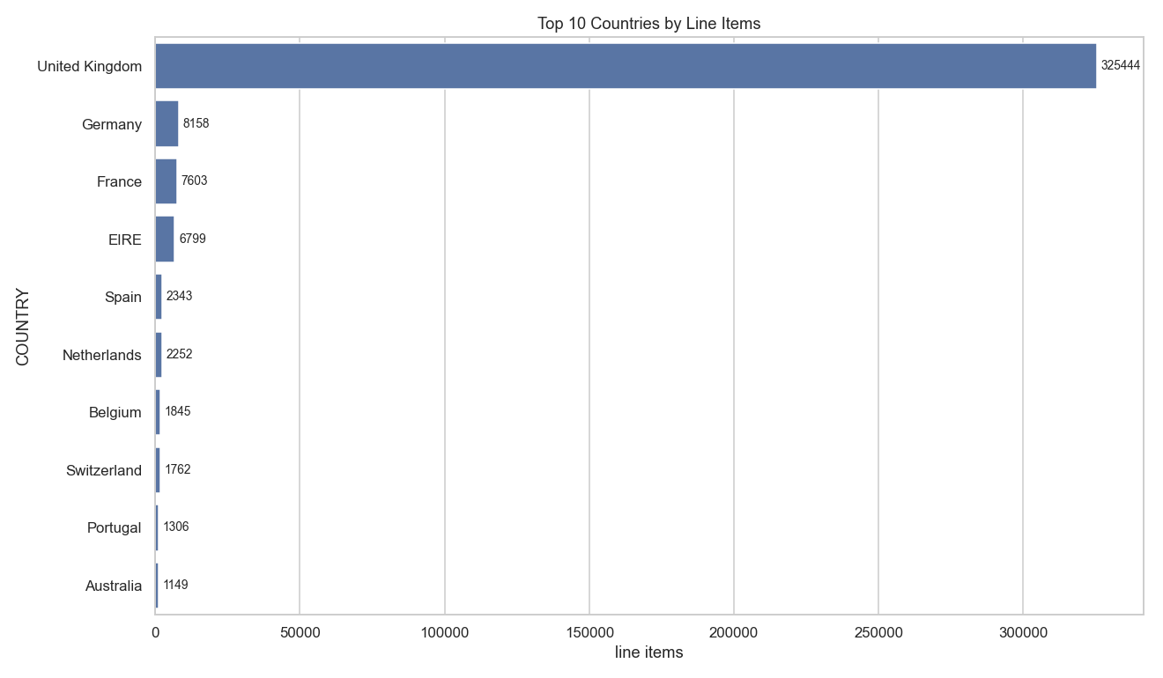
Figure 5. Log-transformed Monetary distribution - approximately normal.
Categorical & Profiling Metrics
Profiling the categorical and identifier attributes clarifies the shape of the data. There are 17,008 distinct invoices across 4,214 customers and 3,590 distinct products, sold into 36 countries. The market is overwhelmingly domestic: the United Kingdom accounts for 89% of all line items, so any segmentation and campaign design should treat the UK as the core market and international customers as a distinct, smaller opportunity.
Attribute | Distinct | Most Frequent Value | Count | % Rows
INVOICE_ID | 17,008 | 576339 | 541 | 0.1%
STOCK_CODE | 3,590 | 85123A | 1,816 | 0.5%
DESCRIPTION | 3,778 | WHITE HANGING HEART T-LIGHT HOLDER | 1,809 | 0.5%
CUSTOMER_ID | 4,214 | 17841 | 7,381 | 2%
COUNTRY | 36 | United Kingdom | 325,444 | 89%
Table 7. Profiling metrics for categorical and identifier attributes.
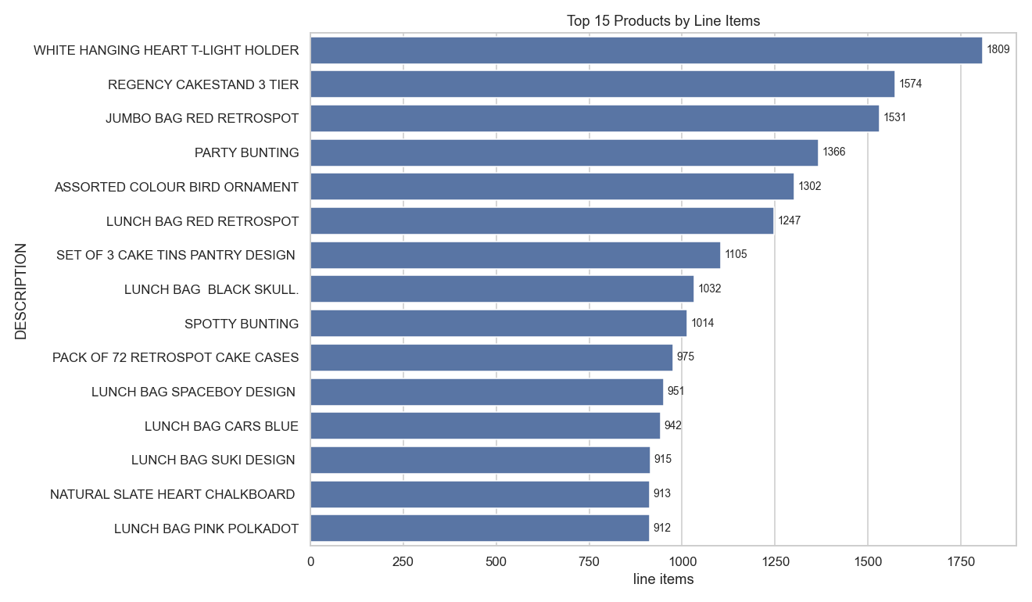
Figure 6. Top 10 countries by line-item volume; the United Kingdom dominates at 89%.
The product mix is classic gift and homeware retail - decorative t-light holders, cake stands, and printed lunch bags lead by volume - which is consistent with the strong end-of-year seasonality below.
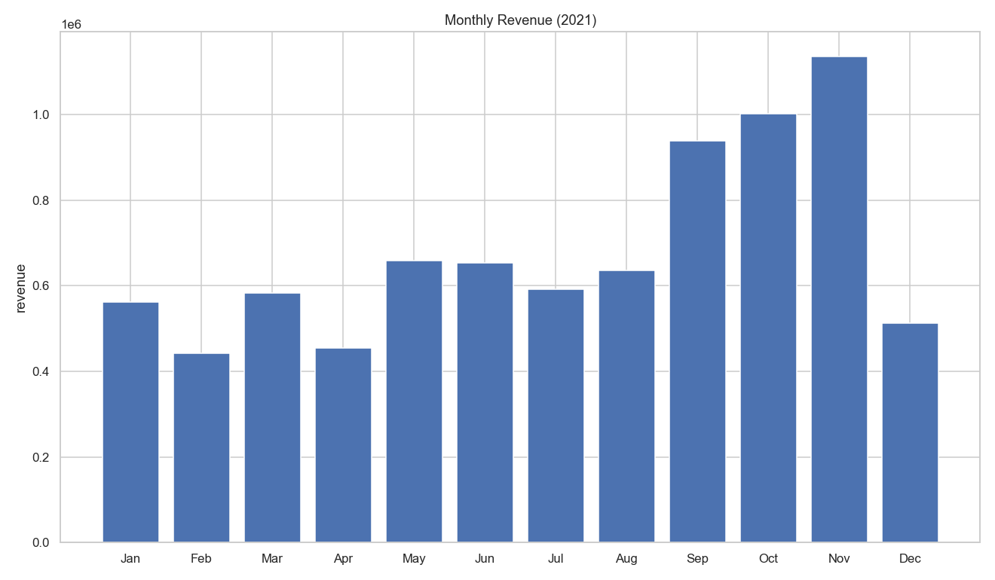
Figure 7. Top 15 products by line-item volume.
Product and Description Analysis
Looking at the highest-value stock codes shows a long-tail assortment rather than a hit-driven one: the top ten codes together account for only 9.9% of revenue, so no single product carries the business. The leader by revenue is worth a closer look — 23843 (PAPER CRAFT , LITTLE BIRDIE) generated GBP 168,470 from a single line item of 80,995 units bought by one customer. That one row is the source of the 80,995 maximum quantity in the cleaned transaction summary, and it is a genuine bulk order rather than an error.
Stock Code | Description | Lines | Units | Customers | Revenue (GBP) | % Rev
23843 | PAPER CRAFT , LITTLE BIRDIE | 1 | 80,995 | 1 | 168,470 | 2.06%
22423 | REGENCY CAKESTAND 3 TIER | 1,574 | 10,820 | 844 | 124,683 | 1.53%
85123A | WHITE HANGING HEART T-LIGHT HOLDER | 1,816 | 33,152 | 818 | 90,945 | 1.11%
85099B | JUMBO BAG RED RETROSPOT | 1,531 | 44,022 | 611 | 81,421 | 1.0%
23166 | MEDIUM CERAMIC TOP STORAGE JAR | 198 | 77,916 | 138 | 81,417 | 1.0%
47566 | PARTY BUNTING | 1,366 | 15,089 | 700 | 67,992 | 0.83%
84879 | ASSORTED COLOUR BIRD ORNAMENT | 1,302 | 33,004 | 652 | 52,760 | 0.65%
23084 | RABBIT NIGHT LIGHT | 823 | 27,153 | 450 | 51,251 | 0.63%
22502 | PICNIC BASKET WICKER SMALL | 210 | 1,364 | 160 | 46,676 | 0.57%
79321 | CHILLI LIGHTS | 457 | 8,176 | 198 | 40,066 | 0.49%
Table 8. Top 10 stock codes by revenue.
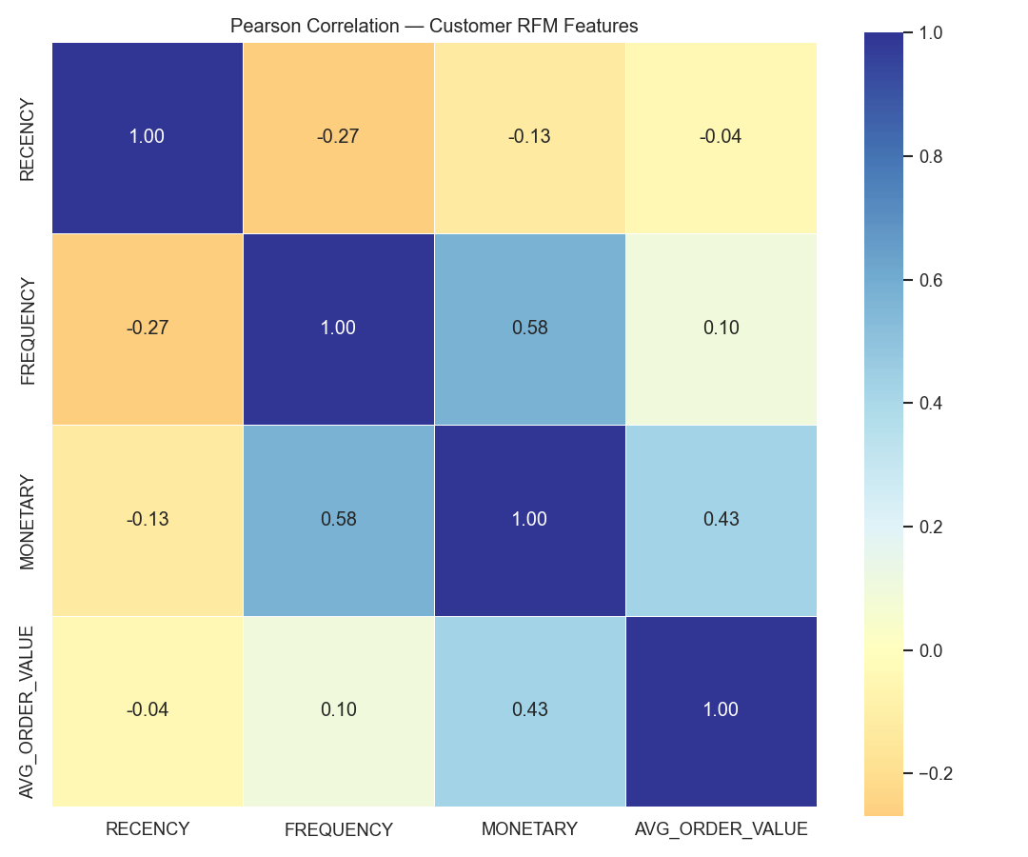
Figure 8. Top 10 stock codes by revenue, labelled with their most common description.
Profiling the description field itself surfaces a data-quality issue that matters for any product-level analysis. Description is free text, and 191 of the 3,590 stock codes (5.3%) carry more than one spelling, up to 4 variants on a single code — mostly typos and abbreviations such as “BICYCLE SAFTEY” for “BICYCLE SAFETY”. A further 19 descriptions are shared across more than one stock code. This is exactly why the cleaned file reports 3,778 distinct descriptions against only 3,590 distinct stock codes. The practical consequence is that StockCode is the reliable product key and Description is not; any grouping of products should be keyed on the code, with the most frequent description attached only as a human-readable label.
Stock Code | Variants | Descriptions Recorded
23236 | 4 | STORAGE TIN VINTAGE DOILY (x160) | DOILEY STORAGE TIN (x113) | DOILEY BISCUIT TIN (x13) | STORAGE TIN VINTAGE DOILEY (x1)
23196 | 4 | VINTAGE LEAF MAGNETIC NOTEPAD (x215) | RETRO LEAVES MAGNETIC NOTEPAD (x19) | RETO LEAVES MAGNETIC SHOPPING LIST (x3) | LEAVES MAGNETIC SHOPPING LIST
23244 | 3 | ROUND STORAGE TIN VINTAGE LEAF (x96) | STORAGE TIN VINTAGE LEAF (x7) | CANNISTER VINTAGE LEAF DESIGN (x2)
23209 | 3 | LUNCH BAG VINTAGE DOILY (x549) | LUNCH BAG DOILEY PATTERN (x467) | LUNCH BAG VINTAGE DOILEY (x4)
23535 | 3 | WALL ART BICYCLE SAFETY (x121) | BICYCLE SAFTEY WALL ART (x39) | WALL ART BICYCLE SAFTEY (x3)
Table 9. Stock codes carrying the most competing descriptions (top 5).

Monthly revenue reveals pronounced fourth-quarter seasonality: revenue climbs sharply from September and peaks in November before the (partial) December, more than doubling the February trough. Campaign timing should account for this holiday-driven cycle.
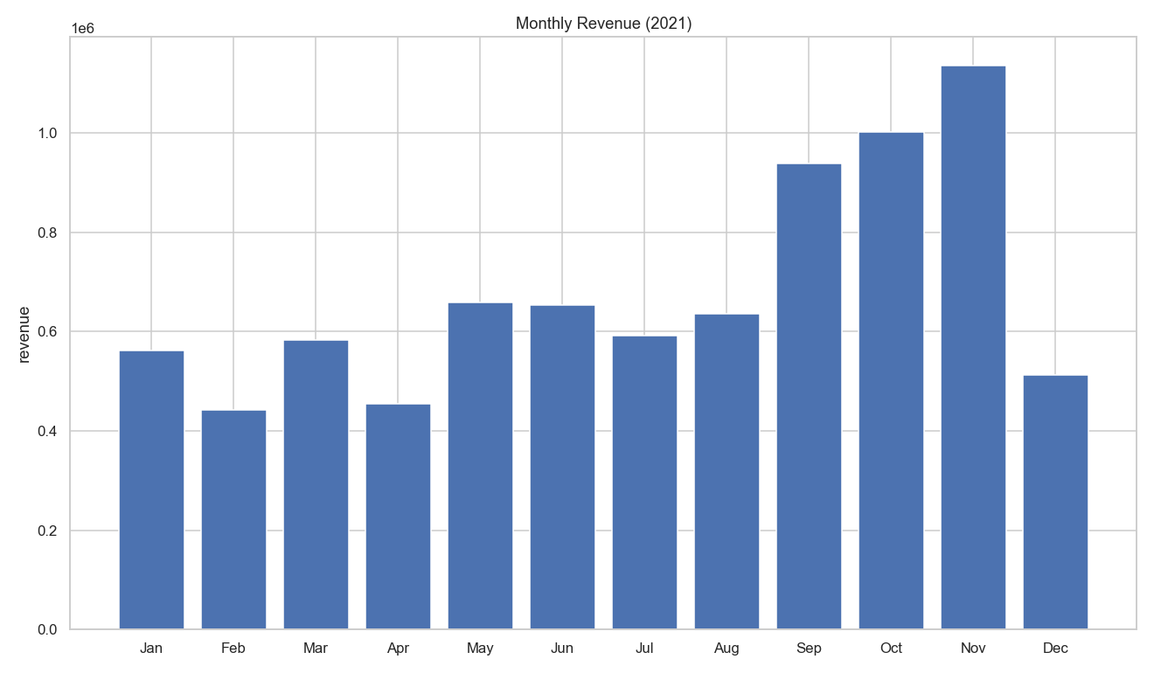
Figure 9. Monthly revenue across 2021.
Trading Patterns by Day and Hour
Breaking the same revenue down by day of week shows a clear midweek concentration. Wed is the strongest trading day at 22.0% of revenue across 3,640 invoices, while Sat is the weakest at 8.9% and also carries the smallest average basket (GBP 358.69 per invoice against GBP 494.63 on Wed). One finding here is a data characteristic rather than a business one: there is no Friday trading anywhere in the file. Not a single record falls on that weekday, in the raw extract as well as the cleaned master, so it is a gap in the source data rather than something cleansing introduced. Any weekly seasonality read from this dataset has to be interpreted with that missing day in mind.
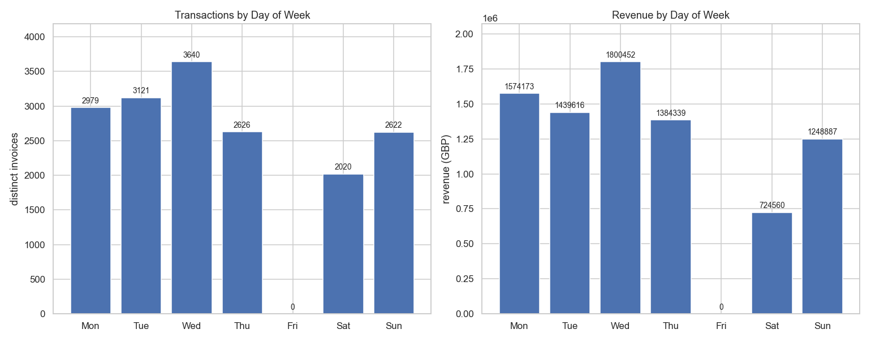
Figure 10. Transactions and revenue by day of week. The absent weekday is shown as a zero bar to make the gap explicit.
Within the day, trading runs from 6:00 to 20:00 and is heavily concentrated in the middle of the working day. The busiest hour is 12:00 with 2,897 invoices, and the 10:00–15:59 window alone accounts for 77.2% of all revenue. Volume before 09:00 and after 17:00 is negligible. This is a B2B-leaning, office-hours purchasing pattern rather than an evening consumer one, which is useful for campaign timing: email and promotional sends land best in the late morning, ahead of the midday peak rather than during it.
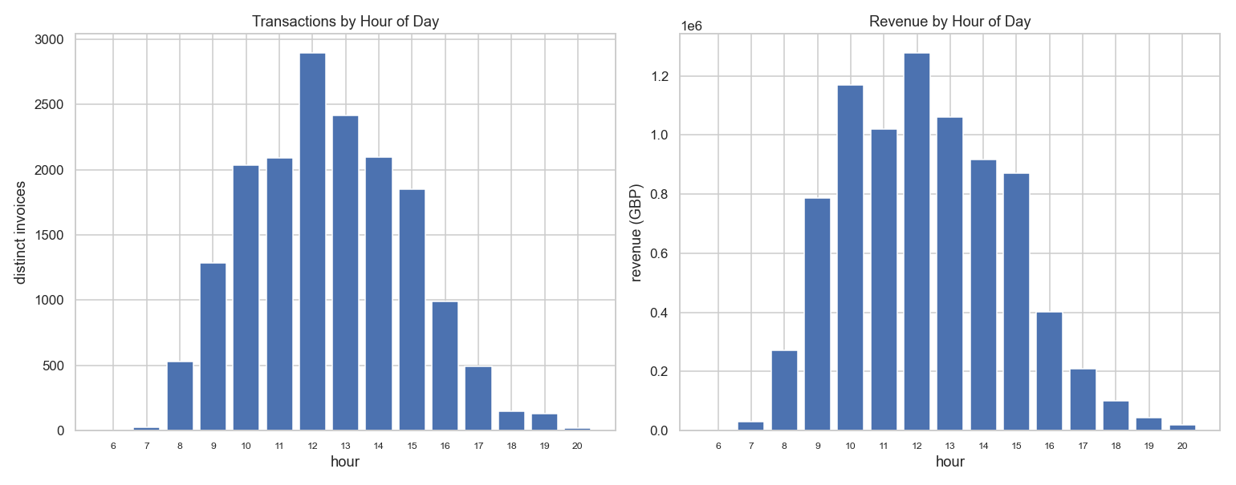
Figure 11. Transactions and revenue by hour of day.

Correlation Matrix
The Pearson correlation matrix over the RFM features confirms that each behavioral axis carries distinct information. Frequency and Monetary are moderately, positively correlated (0.55) - customers who order more often also spend more overall, as expected. Recency is negatively related to both Frequency (-0.27) and Monetary (-0.12): customers who purchased recently tend to be the more frequent, higher-spending ones. Average Order Value is largely independent of Frequency (0.02) and Recency (0.01) and only moderately tied to Monetary (0.41), meaning it captures a genuinely separate dimension of behavior. Because no pair of features is so strongly correlated as to be redundant, all three RFM dimensions are worth retaining for segmentation.
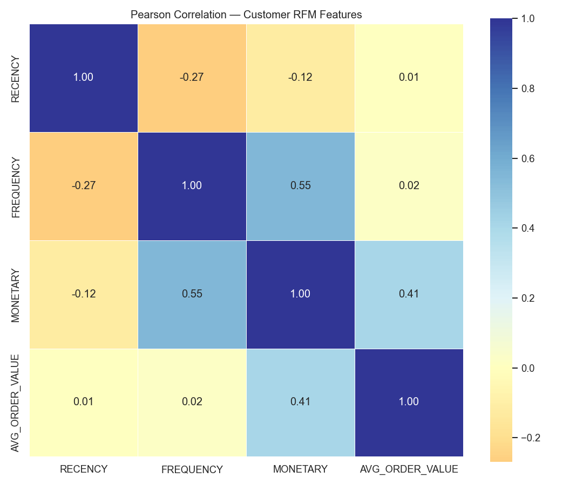
Figure 12. Pearson correlation matrix of customer RFM features.
Is the Data Appropriate and Sufficient?
Yes. After cleansing, the dataset yields a complete, well-behaved, customer-level RFM table for 4,201 customers with no missing values and no redundant features, with monetary value stated net of cancellations. The RFM behaviors are informative and only weakly-to-moderately correlated, which is ideal for unsupervised segmentation. In the next milestone I will scale the RFM features and apply clustering (K-Means, validated with the elbow and silhouette methods, with hierarchical clustering as a cross-check) to produce distinct customer segments - for example, high-value loyalists, at-risk lapsers, and one-time bargain buyers - each of which maps to a concrete, targeted campaign recommendation.

